Statistics and Bioinformatics -- Problem Set 2
Conditional Probability and Bayes' Theorem

Exercises

Chance experiments

- For each of the following, briefly outline a chance experiment that could (in theory) be used to calculate the probability.

  - The probability that a coin lands heads -- flip it many times and record the number of heads
  - The probability that a seed of a cross between two pea plants is yellow -- make many crosses and record the number that are yellow
  - The probability that individuals of a new variety of corn will survive to set seed -- plant many individuals and record the number that survive
  - The probability that this winter will be colder than last winter -- compare historical records of many years with conditions now versus conditions in a normal year.

Conditional probability

- Assume the following probabilities are given: P(A) = 2/8, P(B) = 3/8, P(A intersect B) = 2/8. Illustrate these probabilities with a Venn Diagram.
- Calculate the following quantities, showing your work:
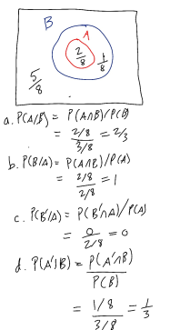
  - P(A/B)
  - P(B/A)
  - P(B'/A)
  - P(A'/B)
  - P(A/B')
  - P(B/A')
  - P(A'/B')
  - P(B'/A')

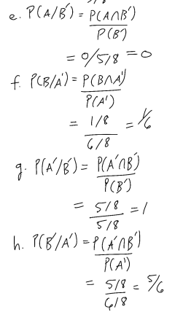

- In a study of the genetics of disease resistance, a random sample of thousands of wheat plants was evaluated. 21% were found to have gene R1. 37% were found to be resistant to fungal attack during summer. 12% were found to both have the gene R1 and to be resistant to fungal attack. Assume that the above percentages are probabilities.

  - Draw an appropriate Venn diagram for this dataset.
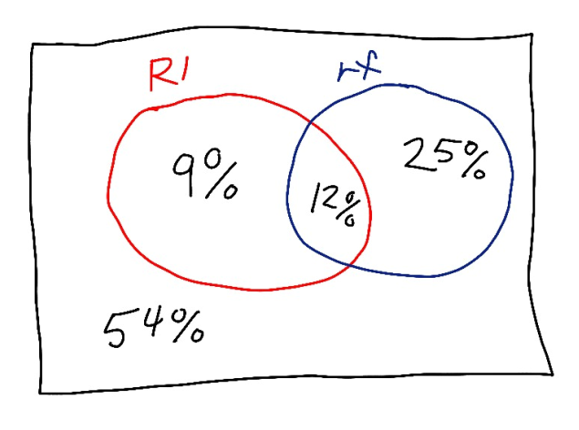
  - What is the probability that a plant does not carry the gene and is resistant to fungal attack? 25%
  - What is the probability that a plant carries the gene and is not resistant to fungal attack? 9%
  - What is the probability that a plant neither carries the gene nor is resistant to fungal attack? 54%
  - What is the probability that an plant carrying the gene will be not resistant to fungal attack? 9/21
  - What is the probability that a plant not carrying the gene will not be resistant to fungal attack? 54/(54 + 25)
  - What is the probability that a plant resistant to fungal attack carries the gene? 12/37
  - What is the probability that a plant not resistant to fungal attack carries the gene? 9/(54 + 9)
  - Are resistance to fungal attack and carrying the gene R1 independent of each other? If not, how do they affect each other? P(rf) = 0.37, P(R1) = 0.21. P(rf)*P(R1) = 0.0777 < 0.12, therefore the two are not independent but affect each other positively.

- Assume A and B are independent. Then what is P(B/A)? =P(B) What is P(A/B)? =P(A)

- If all you know is P(A/B), can you calculate P(B/A)? If not, what do you need to know in addition? No, you need to know in addition the ratio P(B)/P(A) (see Bayes' Theorem).

Union of events

- The probability that a hibiscus flower is pollinated is P(A) = 80%; the probability that a hibiscus flower is not white is P(B) = 80%; the probability that a hibiscus flower is pollinated and is non-white is P(A and B) = 75%. Illustrate these probabilities with a Venn Diagram. Showing your work, calculate the probability that a random hibiscus flower is either:
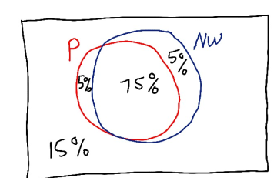

  - non-white or pollinated.
  - non-white or not pollinated.
  - white or pollinated.
  - white or not pollinated.

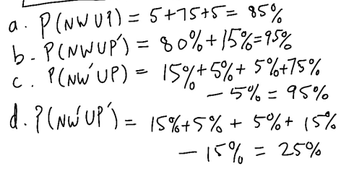

- The concepts of mutually exclusive and independent are often confused. From a biological area of your personal interest, give one good example of:
  - two events that are mutually exclusive, and explain why they are not independent, and
  - two events that are independent, and explain why they are not mutually exclusive.

Problems
Law of large numbers

- Suppose we have a large population of plants, with proportion p infected with a fungus. We want to know estimate that proportion p with a random sample.

  - If p = 0.5, approximately how many plants should we sample to estimate p within 0.4 to 0.6? Within 0.45 to 0.55? Within 0.48 to 0.52?
  - If p = 0.1, approximately how many plants should we sample to estimate p within 0.0 to 0.2? Within 0.05 to 0.15? Within 0.08 to 0.12?
  - If p = 0.9, approximately how many plants should we sample to estimate p within 0.8 to 1.0? Within 0.85 to 0.95? Within 0.88 to 0.92?
(Hint: Use R, and the runmean() function created in class, the sample() function, and the plot() function. First use scan() to create a set to sample with the given p values).
The answers below are calculated them from theory. The students estimated from the graph so their results will be different. However, the sample size for p = 0.5 should be larger than the sample size for p = 0.9 or p = 0.1.

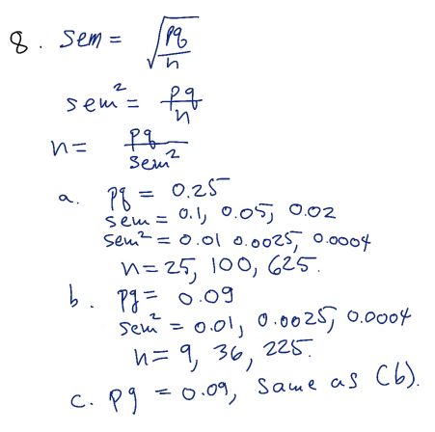

Conditional Probability and Bayes' Theorem

- Assume an HIV test has a false positive rate of 0.02, and also has a false negative rate of 0.02. Assume also that the prevalence of HIV in a particular population is 0.0026 (the approximate value for the entire United States).
  - What is the sensitivity of this test? The specificity? The power? alpha? beta? sensitivity = 0.98, specificity = 0.98, power = 0.98, alpha = 0.02, beta = 0.02.
  - Illustrate this problem with a Venn Diagram, or a probability tree, or a table (your choice).
Disease

Test Yes No Total

Positive 255 1995 2250

Negative 5 97745 97750

Total 260 99740 100000

PPV = 255/2250 = 0.1133

NPV = 97745/97750 = 0.9999

  - If 100,000 people are randomly screened for HIV using this test, how many people can be expected to test positive for the virus? 2250
  - Of that number who tested positive, how many people are expected to actually have the virus? 255
  - Of the number that actually have the virus, what proportion are expected to test positive? 0.98
  - What is the predictive value positive and negative for this test? 0.1133 and 0.9999
  - If you were a doctor counseling a patient who tested positive, what would you advise the patient based on your calculations from this problem? Your chances of having HIV are only 11%, and you should get more testing done.
(Hint: use the SensSpec.demo from TeachingDemos in R to construct the table.)

