Statistics and Bioinformatics
Problem Set 13
Due in class Thursday, January 13, 2011

Do the following problem in a Word file that you email to tosaric@unizd.hr.

- Length of 11 individuals is measured to be 10, 11, 12, 13, 14, 15, 16, 17, 18, 19, and 20. Mass of these 11 individuals is measured to be 1447, 2558, 3096, 3401, 4810, 5870, 6842, 8335, 9910, 12090, and 13926. Assume the true relationship is M = aL^{b}.
  - Using a transformation and the lm() function in R, find the best-fit curve for these data. Paste the results of lm() into your word file. What are your estimates of a and b?
lm(log(y) ~ log(x))

Call:

lm(formula = log(y) ~ log(x))

Coefficients:

(Intercept) log(x)

0.3204 3.0788

a = exp(0.3204) =
1.38
b = 3.0788

  - Using the raw, untransformed data, use nls() in R to estimate a and b. Paste the results of nls() in your Word file. What are your estimates of a and b?

> nls(M~a*L^b, start = c(a = 1, b=3))

Nonlinear regression model

model: M ~ a * L^b

data: parent.frame()

a b

1.405 3.071

residual sum-of-squares: 437421

Number of iterations to convergence: 4

Achieved convergence tolerance: 4.134e-06

a = 1.405
b = 3.071

  - Plot a scatter diagram of L and M. Superimpose on this diagram the best-fit curve using curve(add=T) in R. Include this figure in your Word file.
plot(L, M) or plot(M~L)
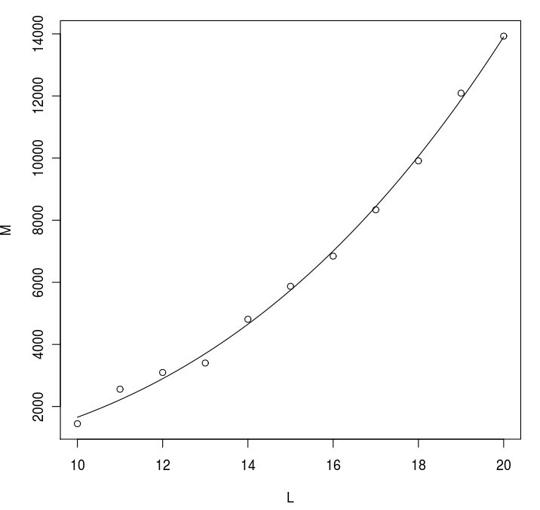
curve(1.405*L^3.071, add=T)

  - If an individual is observed to be 14.5 in length, what is its predicted mass?

M = 1.405*14.5^3.071 = 5165

