Statistics and Bioinformatics
Problem Set 13
Due in class Thursday, January 13, 2011

Present your results for the following problem in a Word file emailed to the assistant tosaric@unizd.hr.

- For the following data points, perform a linear regression. Calculate the mean x, the mean y, the covariance of x and y, the variance of x and y, the correlation coefficient, the sum of squares and mean squares of the line and residuals, the coefficient of determination, and present the ANOVA table. State whether the regression is significant, and state how much of the variation in y is explained. Include in your document a scatter plot of x against y, with the best-fit line drawn through the plotted points.
  - x: number of cricket chirps per second: 20, 16, 19.8, 18.4, 17.1, 15.5, 14.7, 17.1, 15.4, 16.2, 15, 17.2, 16, 17, 14.4.
y: air temperature: 31.4, 22.0, 34.1, 29.1, 27.0, 24.0, 20.9, 27.8, 20.8, 28.5, 26.4, 28.1, 27.0, 28.6, 24.6.
Let's say the number of chirps per second was observed to be 19.0. What do you predict the air temperature to be?

> cov(x, y)

[1] 5.312905

> var(x)

[1] 2.896952

> var(y)

[1] 13.93838

> mean(x)

[1] 16.65333

> mean(y)

[1] 26.68667

> cor(x, y)

[1] 0.8360942

> b = cov(x, y)/var(x)

> b

[1] 1.833963

> a = mean(y) - b*mean(x)

> a

[1] -3.854938

> lm(y~x)

Call:

lm(formula = y ~ x)

Coefficients:

(Intercept) x

-3.855 1.834

> predy = a + b*x

> SSres = sum((y - predy)^2)

> SSres

[1] 58.72591

> SSline = sum((predy - mean(y))^2)

> SSline

[1] 136.4114

> MSline = SSline/1

> MSline

[1] 136.4114

> MSres = SSres/13

> MSres

[1] 4.517378

>

> R2 = SSline/(SSline+SSres)

> R2

[1] 0.6990534

>anova(lm(y~x))

Analysis of Variance Table

Response: y

Df Sum Sq Mean Sq F value Pr(>F)

x 1 136.411 136.411 30.197 0.0001030 ***

Residuals 13 58.726 4.517

For x = 19, y = -3.855 + 1.834*19 = 31.0 degrees.
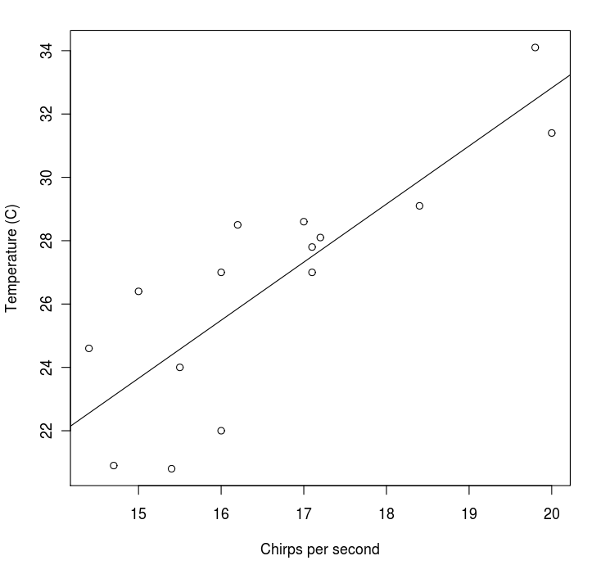
plot(x,y, xlab=”Chirps per second”, ylab=”Temperature (C)”)
abline(lm(y~x))

