Statistics and Bioinformatics
Problem set 11
Due in class, Tuesday, January 4, 2011

Single-factor ANOVA

- “ANOVA” stands for: _____________________________________________.

- A single-factor ANOVA can test up to ________ (one, two, three, four) null hypotheses simultaneously.

- The purpose of single-factor ANOVA is to test the null hypothesis that all __________ (means, variances) are equal in the populations sampled from.

- Why is ANOVA not called analysis of means?

- Write the equation for the groups sum of squares in terms of the group means, the overall grand mean, and the number of groups.

- Write the equation for the within sum of squares in terms of the sample means.

- Write the equation for the within sum of squares in terms of the sample variances.

- Write the equation for the group degrees of freedom in terms of the number of groups.

- Write the equation for the within degrees of freedom in terms of the sample sizes.

- Write the equation for the mean squares groups in terms of the appropriate sum of squares and degrees of freedom.

- Write the equation for the mean squares within in terms of the appropriate sum of squares and degrees of freedom.

- Write the equation for the F value used to test the null hypothesis, and the numerator and denominator degrees of freedom for the test.

Two-factor ANOVA

- A two-factor ANOVA can test up to ________ (one, two, three, four) null hypotheses simultaneously.

- An interaction occurs between factors A and B when the effect of factor A ________ (depends, does not depend) on the level of factor B.

- There are three main reasons a 2-factor ANOVA might be preferable to a 1-factor ANOVA. List these three reasons separately, as follows:
  - Why might a 2-factor ANOVA be preferable if interactions exist?

  - Why might a 2-factor ANOVA be preferable in terms of the coefficient of determination?

  - Why might a 2-factor ANOVA be preferable in terms of the power of the test for a main effect? (refer to the MS_{w} in your answer)

- A drug reduces symptoms by 20% in both men and woman, and without any drug, the symptoms in men are twice as frequent as in women. Is there a sex X drug interaction? Why or why not?

- A drug reduces symptoms by 20% in both men and woman, and without any drug, the symptoms in men are as frequent as in women. Is there a sex X drug interaction? Why or why not?

- For each of the following, either give an example of a table of population means in a 2-factor ANOVA that satisfies the conditions, or explain why it is impossible to satisfy the conditions.
  - main effect of factor A, main effect of factor B, no interaction

  - main effect of factor A, main effect of factor B, yes interaction

  - no main effect of factor A, main effect of factor B, no interaction

  - no main effect of factor A, main effect of factor B, yes interaction

  - no main effect of factor A, no main effect of factor B, no interaction

  - no main effect of factor A, no main effect of factor B, yes interaction

- Write an equation for the cells sum of squares in a 2-factor ANOVA, in terms of the cell means.

- Write an equation for the within sum of squares in a 2-factor ANOVA, in terms of the variances within cells.

- Write an equation for the interaction sum of squares in a 2-factor ANOVA, in terms of the main effects sum of squares and the cells sum of squares.

- The following table is a summary of a study of the predictor variables sex and drug use on the response variable, the total level of observed symptoms of a disease. Calculate and present the full ANOVA table, testing for a drug effect, sex effect, and the interaction. What are your conclusions?

 | Females | Males
No drug | Mean = 5.7, variance = 0.3, n = 20 | Mean = 5.5, variance = 0.25, n = 20
Yes drug | Mean = 5.0, variance = 0.3, n = 20 | Mean = 5.6, variance = 0.20, n = 20

The following problems you will answer within a Microsoft Word file (or equivalent), labeled with your name and the date, that you will email to the TA Tomislav Saric <tosaric@unizd.hr> before the due date for the problem set.

- Following is a raw data table in three colums. The first column is the growth rate of a plant. The second column is the genotype of the plant. The third column is the fertilizer level. Use R to generate the full ANOVA table, testing for a genotype effect, fertilizer effect, and the interaction. Copy and paste this table in your file. What are your conclusions? Is there a genotype-by-environment interaction?

Analysis of Variance Table

Response: growth

Df Sum Sq Mean Sq F value Pr(>F)

gene 1 5.7245 5.7245 5.0432 0.044338 *

fert 1 20.2500 20.2500 17.8401 0.001181 **

gene:fert 1 7.5645 7.5645 6.6643 0.024030 *

Residuals 12 13.6210 1.1351

All three effects are significant. Yes, there is a gene-by-environment interaction.

- Download the file esoph.csv from the course website, www.stewartschultz.com/statistics/course/data, and read it into R with the command esoph = read.csv(“esoph.csv”, header=T). There is one response variable (prev) and three predictor variables (agegp, alcgp, and tobgp). The response variable is the prevalence of esophageal cancer in a population. The predictor variables are the age, alcohol consumption, and tobacco consumption in the sampled population. Perform a two-factor ANOVA to test for main effects of age, alcohol consumption, and their interaction. Copy and paste the full ANOVA table into your Word file. What are your conclusions?

Analysis of Variance Table

Response: prev

Df Sum Sq Mean Sq F value Pr(>F)

agegp 5 3.5050 0.70100 14.9542 1.040e-09 ***

alcgp 3 3.4741 1.15804 24.7039 9.792e-11 ***

agegp:alcgp 15 1.1301 0.07534 1.6072 0.09677 .

Residuals 64 3.0001 0.04688

Strong effects of both age and alcohol consumption on the prevalence of esophageal cancer, however there is no interaction, so we retain the null hypothesis that the effect of alcohol is the same in all age groups.

- Download the file “insectsprays.csv” from the course website and read it into R as above. This file contains two columns, the kind of insecticide spray, and its effectiveness as measured by the number of dead insects it caused in an experiment.
  - Perform a single-factor ANOVA that tests whether there is a difference among the sprays in their mean effectiveness. Copy and paste the full ANOVA table into a Word file.

Analysis of Variance Table

Response: count

Df Sum Sq Mean Sq F value Pr(>F)

spray 5 2668.8 533.77 34.702 < 2.2e-16 ***

Residuals 66 1015.2 15.38

Highly significant effect of spray type on the number of dead insects (count).

  - Make a boxplot of the effectiveness of each of the insecticide sprays, using the boxplot() function. Copy and paste the plot into your Word file.
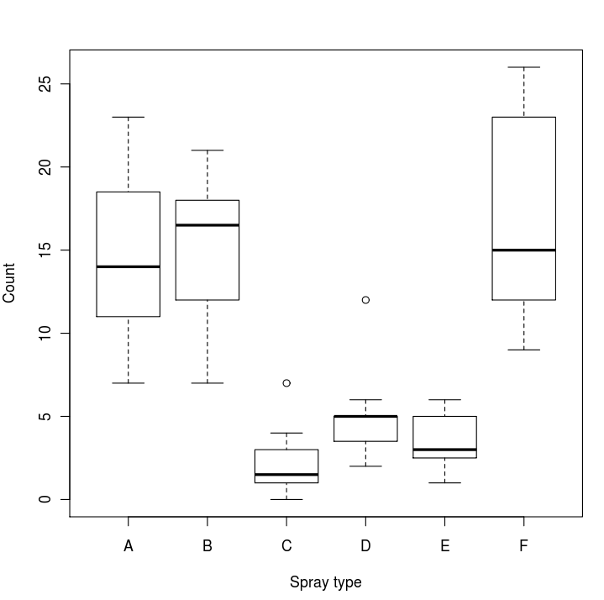

  - Use the R function TukeyHSD() to perform all possible t-tests between all pairs of insecticide sprays, and copy and paste the results into your Word file.
Tukey multiple comparisons of means

95% family-wise confidence level

Fit: aov(formula = count ~ spray)

$spray

diff lwr upr p adj

B-A 0.8333333 -3.866075 5.532742 0.9951810

C-A -12.4166667 -17.116075 -7.717258 0.0000000

D-A -9.5833333 -14.282742 -4.883925 0.0000014

E-A -11.0000000 -15.699409 -6.300591 0.0000000

F-A 2.1666667 -2.532742 6.866075 0.7542147

C-B -13.2500000 -17.949409 -8.550591 0.0000000

D-B -10.4166667 -15.116075 -5.717258 0.0000002

E-B -11.8333333 -16.532742 -7.133925 0.0000000

F-B 1.3333333 -3.366075 6.032742 0.9603075

D-C 2.8333333 -1.866075 7.532742 0.4920707

E-C 1.4166667 -3.282742 6.116075 0.9488669

F-C 14.5833333 9.883925 19.282742 0.0000000

E-D -1.4166667 -6.116075 3.282742 0.9488669

F-D 11.7500000 7.050591 16.449409 0.0000000

F-E 13.1666667 8.467258 17.866075 0.0000000

  - Which sprays are significantly different from each other? What do you conclude from this analysis?

There are two groups of sprays, CDE and ABF; no significant differences within each group, but all sprays within the first are significantly different from those in the second.

- Email your Word file, labeled with your name and date, to Tomislav Saric <tosaric@unizd.hr> for grading.

