- Today chi-square and Z revisited
  - Population, sample diagrams
  - Give data, gallup poll
  - Do a Z test, get result
- Alternative method, chi-square test
  - Make big data table, with columns for expected
  - Definition of chi square: sum of observed minus expected, divided by expected
  - “Expected” is under the assumption that the two “events” are independent of each other: i.e. political party is independent of opinion about whether this is a good decision

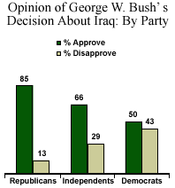

Do you approve or disapprove of Bush's decision to go to war if Saddam Hussein does not leave Iraq in the next 48 hours?

Table of observed
approve | disapprove
337 | 51 | 388
209 | 179 | 388
546 | 230 | 776

Table of expected
273 | 115 | 388
273 | 115 | 388
546 | 230 | 776

Table of chi squares
15.003663 | 35.6173913
15.003663 | 35.6173913

chi-square | 101.2421086
v | 1
crit chi square | 3.841455338
Prob | 8.14004E-24

Table of observed proportions
0.868556701 | 0.1314433 | 1
0.538659794 | 0.46134021 | 1

Z test
tails | 2
Zcrit | 1.95996279
numerator | 0.32989691
overall p | 0.70360825
denominator | 0.0327867
Z | 10.0619138
95 CI for delta high | 0.39415883
95 CI for delta low | 0.26563498
minimum delta | 0.11803089

